For this assignment, you will solve problems based on what you have learned in Chapter: Arrays.

Instructions

- Review the chapters from the book and class notes.
- There are 5 questions in this assignment.
- Assignment submitted after due date will not be evaluated.

Due Date and Time: August 28, 2019, in class.

Submitting this Assignment

You do not have to submit this assignment. When you have completed solving all questions, show them to the Instructor.

Grading Criteria

There are no marks to this assignment.

Questions:

- Write a sort method that uses the bubble-sort algorithm. Write a test program that reads in 10 double numbers in an array, invokes the method, and display the sorted numbers.
- Write a program to implement the binary search algorithm to search an element in the sorted list. If the input elements are not sorted then use the sort (defined in Question1) method before calling binary search method.

- Write a program that create an char type array of 40 lowercase letters randomly and count the occurrence of each letter in the array.

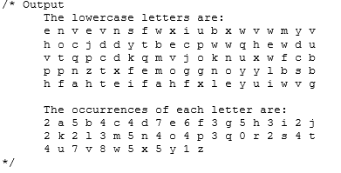

- write a program that grades multiple-choice test.
a. Suppose there are eight students and ten questions, and the answers are stored in a twodimensional array.
b. Each row records a student’s answers to the questions, as shown in the following array:
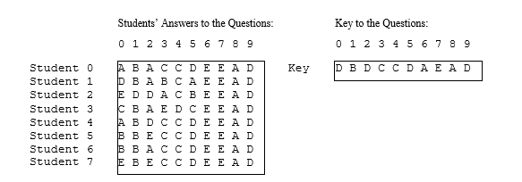

- Write a program that takes set of two dimensional points as input (shown in figure) and finds a closest pair of points.

